***Weather App***

**Group Members:**

Ifrah Zulfiqar FA21-BCS-064

Rida Abid FA21-BCS-007

* **Description:**

Provides the user with accurate weather information based on the location (city) entered. The program uses web scrapping to collect data from google. Our program provides information like temperature, pressure, day and time, humidity, visibility, and wind. We fetch data and convert it into HashMap, integrate it into our program, and display the data on screen using GUI.

Our project uses Javafx, File Handling, and web scraping.

**Details of Scenes in application:**

The first is for the login page, the second scene is created for the Sign-Up page (to create a new account), the third scene takes input on a text field for the city whose temperature you want to view, and the next scene displays the required current data regarding temperature on the screen. This scene also contains buttons that can display data for the next 7 days including the present day.

* **Description of Login class:**

The login class contains two buttons ‘sign-in’ and ‘sign-up’. When the user enters the username and password in specified text fields and presses the sign-in button, the entered data is verified with data in the file using file handling to check if the entered data is correct or incorrect. If the data entered is incorrect the title of the window changes to ‘invalid username or password’. The sign-up button is used if the user does not already have an account and wants to create an account. This class also contains two functions ‘reader’ and ‘writer’ which when called read and write data in the file ‘data.txt’ respectively. This class also contains a reference to the showPass class through the use of which we can show the hidden password in the password field. The stage is set as such it is not resizable.

* **Code of Class LOGIN:**
* package org.example;  
    
  import javafx.application.Application;  
  import javafx.event.ActionEvent;  
  import javafx.event.EventHandler;  
  import javafx.geometry.Insets;  
  import javafx.geometry.Pos;  
  import javafx.scene.Cursor;  
  import javafx.scene.Scene;  
  import javafx.scene.control.*;  
  import javafx.scene.image.Image;  
  import javafx.scene.layout.*;  
  import javafx.scene.text.Font;  
  import javafx.scene.text.Text;  
  import javafx.stage.Stage;  
    
  import java.io.File;  
  import java.io.FileNotFoundException;  
  import java.io.FileWriter;  
  import java.io.IOException;  
  import java.util.ArrayList;  
  import java.util.HashMap;  
  import java.util.Scanner;  
    
  public class Login extends Application {  
    
   public static ArrayList<HashMap <String , String> > *data* = new ArrayList<>();  
   public static HashMap<String, String> *dummy* = new HashMap<>();  
   static File *file* = new File("data.txt");  
   public static void reader() throws Exception {  
   Scanner reader = new Scanner(*file*);  
   while(reader.hasNext()) {  
   String readData = reader.nextLine();  
   *dummy*.put("name", readData.toString().split("_")[0]);  
   *dummy*.put("pass", readData.toString().split("_")[1]);  
    
   *data*.add(*dummy*);  
   *dummy* = new HashMap<String, String>();  
   }  
   reader.close();  
    
   }  
    
   public static void writer(String username, String password) throws IOException {  
   FileWriter fw = new FileWriter("data.txt", true);  
   fw.write("\n");  
   fw.write(username + "_" + password);  
   fw.close();  
   }  
    
   @Override  
   public void start(Stage stage) throws Exception {  
   CheckBox show = new CheckBox();  
   stage.setTitle("Weather App");  
   Label label = new Label("LOGIN PAGE");  
   label.setFont(new Font("Calibri" , 30));  
   HBox hb = new HBox(label);  
   hb.setAlignment(Pos.*CENTER*);  
   hb.setPadding(new Insets(50,30,10,30));  
   BorderPane border = new BorderPane();  
   border.setTop(hb);  
    
    
    
   Text username = new Text("Username");  
   Text password = new Text("Password");  
   TextField user = new TextField();  
   user.setStyle("-fx-border-radius: 15px; -fx-background-radius: 10px; -fx-background-color: #FEFEFE; -fx-text-fill: #000001; -fx-margin: 10px; -fx-font-size: 15");  
   PasswordField passwordField = new PasswordField();  
   passwordField.setStyle("-fx-border-radius: 15px; -fx-background-radius: 10px; -fx-background-color: #FEFEFE; -fx-text-fill: #000001; -fx-margin: 10px; -fx-font-size: 15");  
   Button signin = new Button("SIGN IN");  
   signin.setStyle("-fx-border-radius: 30px; -fx-background-radius: 15px; -fx-background-color: #5F6164; -fx-text-fill: #FEFEFE; -fx-margin: 10px; -fx-font-size: 12");  
   Button signup = new Button("SIGN UP");  
   signup.setStyle("-fx-border-radius: 30px; -fx-background-radius: 15px; -fx-background-color: #5F6164; -fx-text-fill: #FEFEFE; -fx-margin: 10px; -fx-font-size: 12");  
   signup.setCursor(Cursor.*HAND*);  
   signin.setCursor(Cursor.*HAND*);  
   String userstr = "Enter Username";  
   String pswrd = "Enter Password";  
   user.setPromptText(userstr);  
   passwordField.setPromptText(pswrd);  
    
   HBox hb2 = new HBox();  
   hb2.getChildren().addAll(signin , signup);  
   hb2.setSpacing(5);  
    
   GridPane layout = new GridPane();  
   layout.add(username , 0 , 0);  
   layout.add(user , 1 , 0);  
   layout.add(password , 0 ,1);  
   layout.add(passwordField , 1 ,1);  
   layout.add(show,2,1);  
   layout.add(hb2 , 1 ,2);  
   layout.setAlignment(Pos.*CENTER*);  
   layout.setVgap(20);  
   layout.setHgap(20);  
   show.setText("Show Password");  
   layout.setPadding(new Insets(10));  
   border.setCenter(layout);  
    
    
   StackPane stackPane = Transition.*transit*(stage);  
   stackPane.getChildren().add(border);  
   Scene scene = new Scene(stackPane,800,500);  
    
    
   signin.setOnAction(new EventHandler<ActionEvent>() {  
   @Override  
   public void handle(ActionEvent actionEvent) {  
   if(!(user.getText().equals("") && passwordField.getText().equals(""))) {  
   for (HashMap<String, String> i:*data*) {  
   if (i.get("name").equals(user.getText()) && i.get("pass").equals(passwordField.getText())) {  
   user.setText("");  
   passwordField.setText("");  
    
   stage.setTitle("Weather App");  
   new City(stage, scene);  
   return;  
   } else {  
   stage.setTitle("Invalid password or username");  
   }  
   }  
   }else{  
   Alert a = new Alert(Alert.AlertType.*WARNING*);  
   a.setContentText("Plz enter Username and Password if you already have an account.\nOtherwise create an account by signing up");  
   a.show();  
   }  
   }  
   });  
    
   signup.setOnAction(new EventHandler<ActionEvent>() {  
   @Override  
   public void handle(ActionEvent actionEvent) {  
   new SignUpPage(stage, scene);  
   }  
   });  
   show.setOnAction(new ShowPass(passwordField,show,layout));  
   stage.setScene(scene);  
   stage.setResizable(false);  
   stage.show();  
   }  
    
   public static void main(String[] args) throws Exception {  
   *reader*();  
   *launch*(args);  
   }  
  }
* **Screen Shots of Running Program:**

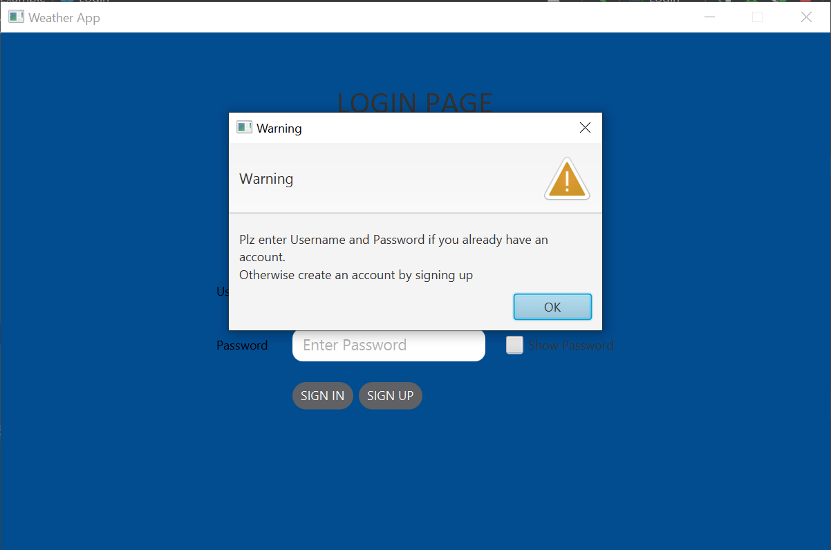

Fig: Warning alert when sign-in is attempted when text fields are empty

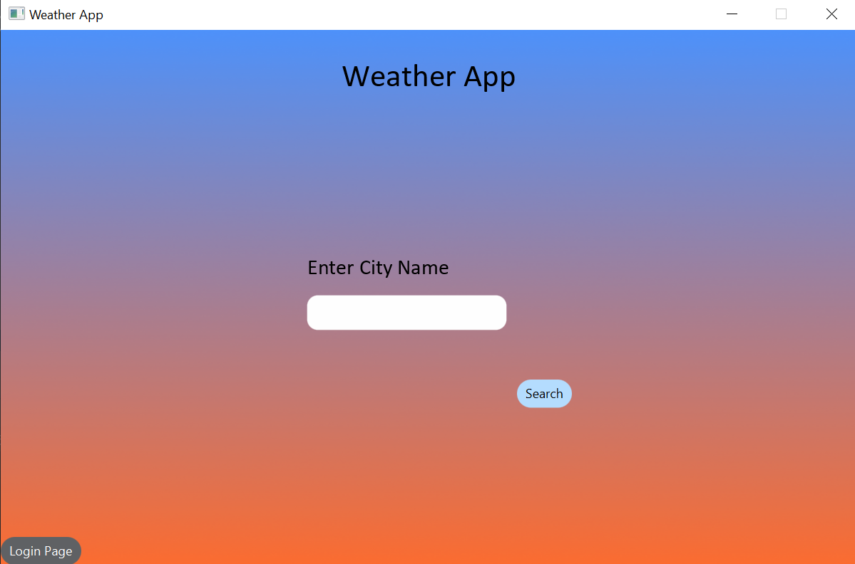

Fig: Adding city name in text field to search temperature

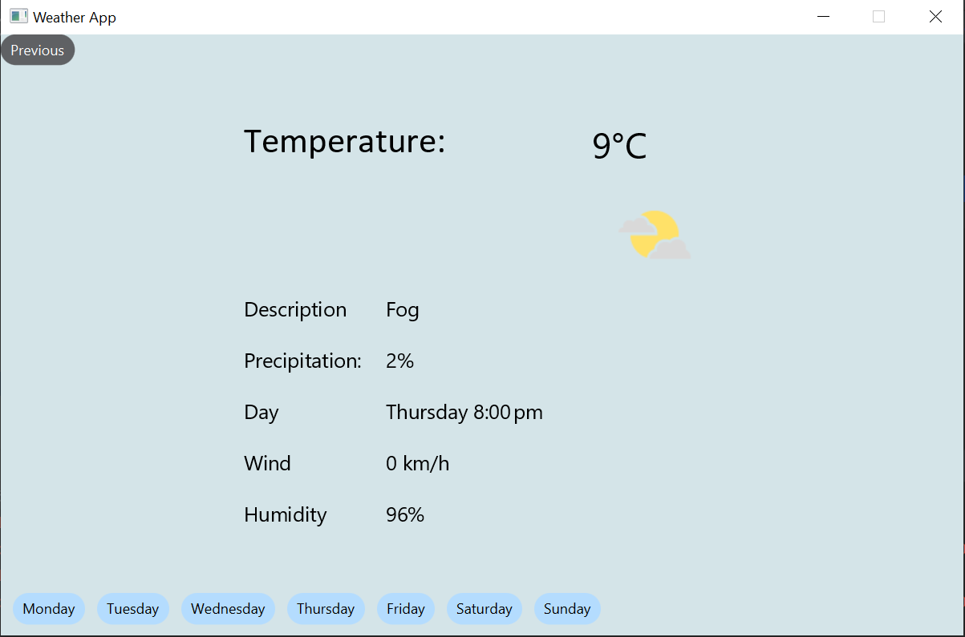

Fig: Temperature and details of the searched city (Lahore)

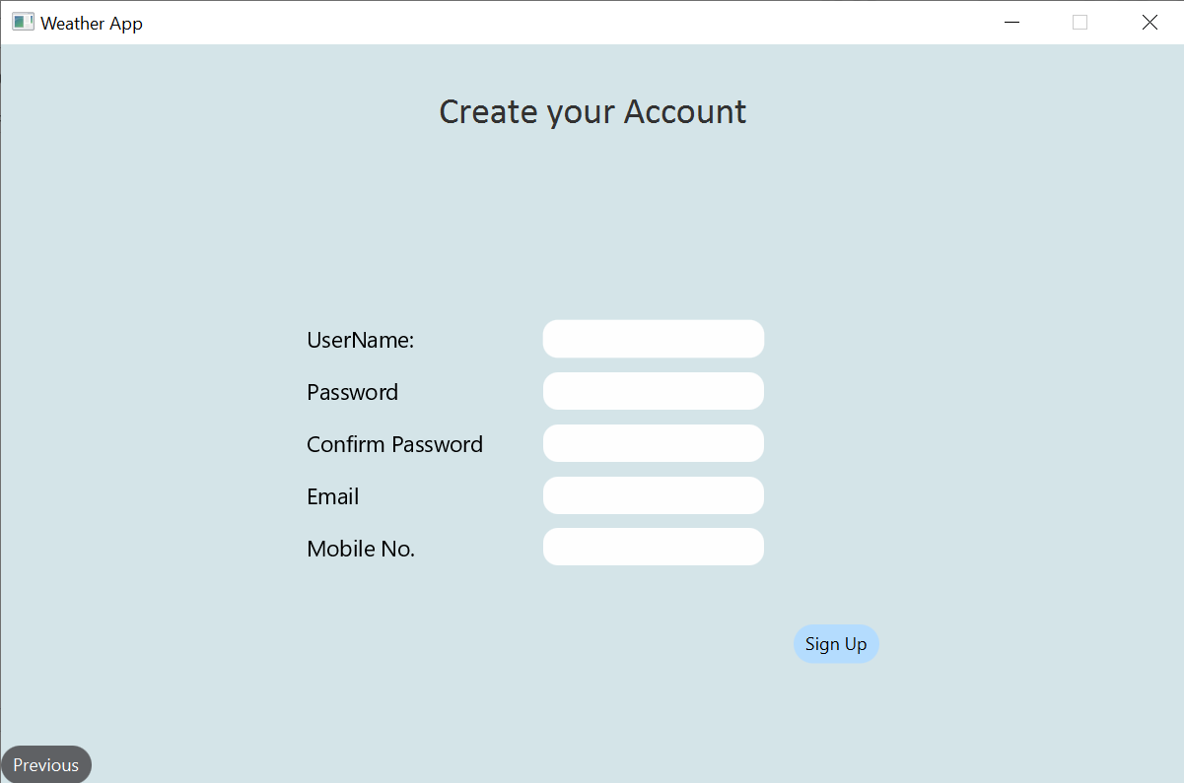

Fig: Sign-up page for creating a new account